Overcoming the Barriers of Employee Engagement in Corporate Sustainability
Hui-Yun Hou MSc., Dr. Lonneke Roza, Dr. Guido Berens

Businesses worldwide increasingly recognize the urgency and responsibility of transforming business operations toward a more sustainable way. From a business perspective, such a transformation is necessary to maintain competitive advantage in markets and to ensure a future “license to operate” in society. Sustainability transition is a long-term change that involves fundamental changes in systems, processes, operations, technology, and people. To achieve sustainable transformation, a fundamental question for many businesses today is how to make the transition smoother. To bring about this transition successfully, employee engagement is crucial. Employees are the key people who execute the implementation of sustainability strategies and carry out the responsibility of making sustainable decisions in their roles.

Managers as change agents
Indeed, employees are the first-line implementers of corporate policies and practices, and the sustainability manager's job is to stimulate, engage and encourage them to take action. Whilst for some employees, sustainability is an explicit part of their job description, for most employees, participation in corporate sustainability initiatives is voluntary and/or extra-role behaviour. The latter implies that employees have the right to choose whether they want to participate or to what extent they want to be involved. But to truly be successful in the transition towards sustainability, refraining from such behaviour is not a viable option anymore as sustainability should be integrated into every job. We should, therefore, learn more about how managers can stimulate and encourage sustainable action among employees.
To find the answers, one of us, Hui-Yun Hou, conducted an exploratory study for her master thesis on the challenges that corporate sustainability managers are facing in their organizations. The research is based on 12 interviews with corporate sustainability managers from different industries. The findings suggest that the main challenge for most managers is how to stimulate employees to value corporate sustainability and more importantly, to actively and constantly prioritize corporate sustainability-related tasks and have this on top of their minds. According to some managers, even if employees care about sustainability and think it is important, it does not mean that they can fairly prioritize related tasks at work. Employees are often distracted by other issues that are considered more urgent. That is to say, employees might agree with the importance of corporate sustainability tasks or initiatives but do not think the tasks are urgent to take actions.

How to overcome barriers in employee engagement in Corporate Sustainability
Our research not only helps us understand why employees might refrain from engaging in sustainability, but also gives us cues on what managers can do to overcome these barriers. We found that two main axes are of importance here, corresponding to the axes of the well-known Eisenhower Matrix (see figure 1). The first axis represents the extent to which employees feel that the task or responsibility is important to them, and the second axis the extent to which employees feel that the task has a sense of urgency for them.
Figure 1: Eisenhower Matrix

Based on this matrix, we identify five main strategies (see figure 2):
- Moving from unawareness to awareness
- Aligning values between employees and the organization on sustainability
- Moving from no action to action
- Increasing intrinsic motivation
- Internalizing sustainability into employee mindset

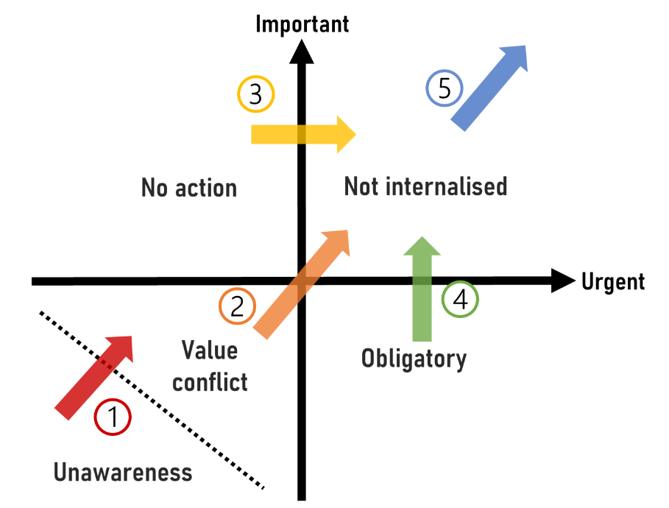
Figure 2: Employee engagement in Corporate Sustainability Matrix

- Moving from unawareness to awareness
The first and most fundamental challenge is the unawareness of sustainability in organizations. Employees need to be aware of the company’s sustainability vision and efforts first in order to be further stimulated to work on sustainability-related tasks. Unawareness means that sustainability tasks are neither important nor urgent for them to tackle. The research identifies three types of unawareness that many sustainability managers are facing: unawareness of the company’s efforts on sustainability, unawareness of what the company means by sustainability, and unawareness of support that the company provides. Most managers are working on raising awareness of sustainability in their organization, but a massive amount of published information within the organization reduces the effect of this approach. Thus, sustainability managers can rethink how to make their messages more visible to employees and to set up a structural communication approach.

- Aligning values between employees and the organization on sustainability
In some instances, the values or beliefs of employees or senior managers are not aligned or contradictory to organizational sustainability goals. When value conflict happens, sustainability is neither important nor urgent for employees to tackle. This is the issue most frequently mentioned by corporate sustainability managers. Many sustainability managers think it is an unavoidable barrier that will take them a lot of time and effort to overcome. This barrier can manifest itself in issues such as: “employees are not interested in sustainability”, “senior managers are not interested in sustainability”, “company’s goal does not align with individual’s goal”, “short-termism vs. long-termism”, and “negative stereotype of sustainability”. Here, managers can stimulate employees by linking the impact of their sustainability efforts with employee’s existing interests, such as their passion, purpose or social goals. This might result in increasing the importance or/and urgency of sustainability-related tasks to employees.

- Moving from no action to action
Employees might agree with the importance of sustainability-related tasks or initiatives but at the same time do not take action or only work on other more urgent tasks. Several managers recognized there is a big gap between the numbers of employees who recognize the importance of sustainability and the number of employees who are actively taking action on sustainability. This can be overcome by creating survival anxiety and increasing the urgency of sustainability-related tasks to employees. Here, it is important to understand what helps people accept changes and take actions. According to the interviews, all managers are using their own way to help their employees adapt to the organizational sustainability transition. According to Schein’s theory of individual change, when experiencing change, there are two competing forces at play within individuals’ minds to determine whether to embrace the change, which are learning anxiety and survival anxiety. Learning anxiety is associated with worries about having to learn something new as a result of the change. Survival anxiety is associated with concerns about what will happen if an employee does not accept the change.
Instead of focusing on creating survival anxiety, most corporate sustainability managers in the interviews are focusing on creating psychological safety, such as providing a supportive environment, training, knowledge, and tools, and increasing the practicability of sustainability strategies. Although creating anxiety is not what change management researchers suggest leaders do, these researchers still recognize that if survival anxiety is way too small, it is difficult to make people accept change and take action. Thus, instead of providing support only, corporate sustainability managers can think about how to leverage the element of anxiety. For example, managers can show employees that sustainability is valued by their senior managers and send employees a clear message that their company is taking sustainability seriously. Also, they can emphasize how sustainability is affecting their business interests. In this way, employees might start to feel concerns about what happens if they do not take action, and to feel the urgency of taking action.

- Increasing intrinsic motivation
Employees might work on sustainability only because they are told to do so. They feel the obligation of working on it. Once the external pressure is gone, employees will not be involved anymore because they do not have the intrinsic motivation to work on sustainability. Several corporate sustainability managers also recognized that voluntary involvement creates more significant impacts than obligatory involvement. Thus, managers try to make employees not only feel “I have to”, but also feel “I want it myself”. In that way, sustainability is more embedded in the hearts of employees, and not something employees do because they have to. For this to happen, employees must develop intrinsic motivation for working on sustainability. Managers can be supportive by finding out employee’s personal interests and linking them to sustainability-related projects. Also, managers can try to stimulate employee’s passions and emotions by outlining a big dream and sustainability mission. Another effective way is creating fun and rewarding employee’s sustainability efforts, which only half of the managers interviewed were trying to do in their organizations. Thus, corporate sustainability managers can think about how to create attractiveness through (serious) games or providing rewards. These approaches are especially critical when managers want to keep employees engaged. Like one manager said in the interview: “[Keeping employees engaging] is not always that easy because sustainability is something for the long-term and very difficult to create a short-term success. So, on the one hand, it is really all about celebrating victories.”

- Internalizing sustainability into employee mindset
Although at this stage, employees are valuing sustainability and working on it, this does not mean that the task of promoting employee engagement is done. Here, sustainability managers try to get sustainability internalized into their employees’ full mindset and bring employee engagement to the next level. For example, employees can become active promotors and ambassadors of sustainability within the company, but only want to do so - and only can legitimately do so - if they ‘live’ it. To accomplish this, some corporate sustainability managers are encouraging employees to propose their own ideas and empowering employees in the decision-making process. Increasing opportunities for employee autonomy in corporate sustainability is a way to help employees internalize sustainability into their mindset.

How to move forward
Corporate sustainability is a critical topic in organizational transformation. In this transition, corporate sustainability managers act as intermediaries who create impact through employees in their organizations. Employees are the actual executor, and corporate sustainability manager’s job is to wake the executors up and encourage them to take action. To stimulate employee engagement and participation, it is vital for corporate sustainability managers to not only look at what drives employee engagement but also look at what prevents employees from prioritizing sustainability-related tasks at the workplace.

