BACHELOR APPLICATION FORM
Spring 2022
all fields need to be completed!

Personal information
First name
Last name
Nationality
Address
Postal Code, City
Telephone number
Mobile phone number
EUR email address |  | @ | student.eur.nl
Private email address |  | @

RSM study
At the moment of participation I will be enrolled in (please tick) | BA | IBA
Year 1
Year 2
Year 3

Language skills
Please indicate your level of proficiency for Dutch (if applicable) and English:
Dutch
English

Incoming exchange students
We will assign every Exchange Ambassador to exchange students from different universities. Your preferences are considered where possible.
My preferences (country and/or university):

Availability during the period January - June
See application requirements!
X | I will attend the mandatory introduction on Friday 7 January 2022
I will NOT be in the Netherlands, but reachable by email:
From: |  | To:
I will NOT be reachable by email:
From: |  | To:

Photo (passport size is preferred)
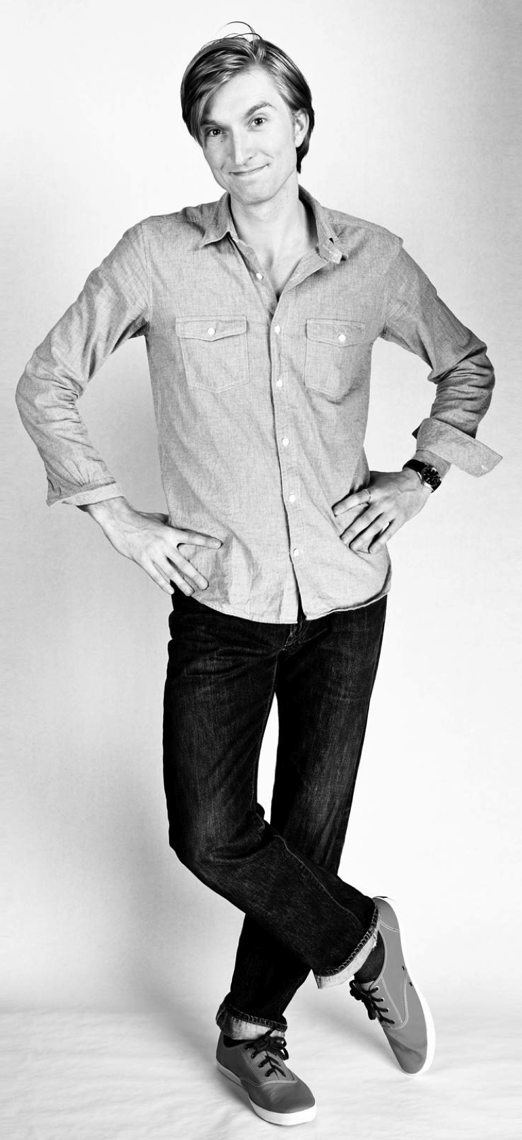
Please insert your photo in the field here below. We will use this photo in the information for our exchange students.
Insert photo here:

Motivation letter
Explain briefly in English why we should select you to join the RSM Exchange Ambassador programme (max. 200 words):

Date
Name

Application requirements

- Enrolled in the Bachelor 1, 2 or 3 from BA or IBA at the moment of participation;
- Strong motivation for participation (open-minded, enthusiastic, and willing to help others etc.);
- Availability:
- to be in contact with the students by email as of month of December
- to assist them with their arrival and settling in December/January
- to participate in the introduction activity: Friday January 7th, 2022
- to be the first contact during the exchange period.

Application procedures

Deadline application form: Sunday 28 November 2021
Application form by email to: vermeulen@rsm.nl

